OUR JOURNEY · PAST PROJECT (2022–2023)
Project Ravi Kiran
Turning Sunlight and Surplus Harvest into Livelihoods for Rural Women
A CSR-funded solar dehydration initiative that gave rural women in Jammu & Kashmir and Telangana a dignified, zero-energy-cost livelihood — while rescuing tonnes of fruit and vegetables that would otherwise have gone to waste.
Location: Qazigund, Anantnag, J&K | Location: Dichpally, Nizamabad, Telangana | Timeline: Aug 2022 – May 2023 | CSR Partner: NIIF / Athaang

2 | ~45+ | 34–58 T | ₹0
Project sites — J&K & Telangana | Rural women given direct livelihood (Year 1 target) | Fruit, veg & herbs solar-dried per year (combined Year-1 plan) | Energy cost — 100% solar-powered drying

THE PROBLEM WE SET OUT TO SOLVE
35–40% of India's fruits and vegetables never reach a consumer
Across rural India, large quantities of fruit, vegetables and herbs perish every season for want of basic preserving, processing and marketing infrastructure. Industry estimates suggest that 35–40% of all fruits and vegetables produced never reach the end consumer — rotting in fields, in transit, or in unsold market stock. As this food waste decomposes, it releases methane, a greenhouse gas nearly 23 times more potent than CO₂.
Project Ravi Kiran was Gramonnati Trust's answer to this problem — built around a simple, elegant technology: solar dehydration. On an average day, sunlight delivers roughly 1,367 watts of heat energy per square metre. By drawing warm, dry air across the surface of fruits and vegetables, a solar dryer removes 80–90% of their moisture at an ambient temperature of 55–65°C — with zero electricity, zero fuel, and zero emissions. The result: nutritious, shelf-stable dried produce, and a sustainable livelihood for the rural women who run the drying units.
The project integrated three goals: rescuing perishable produce from farmers and FPOs, creating dignified livelihoods for rural women, and building environmentally sustainable micro-enterprises replicable across other regions.

WHERE WE WORKED
Two Sites, One Model
Backed by CSR funding from NIIF (National Investment & Infrastructure Fund) through its CSR implementation partner Athaang, Gramonnati Trust signed its MoU on 3 August 2022 and set up solar drying facilities at two very different ends of the country.
Qazigund, Jammu & Kashmir  Village Mandipora, Tehsil Dooru, District Anantnag — 4 km from the Banihal Tunnel  - Funds sanctioned: 13 September 2022  - Site occupied: 15 December 2022, after surveying 12–15 candidate sites  - Soft launch: 11 March 2023, with Athaang GM Mr Aftab Darvesh  - Produce: Kashmiri apples, plums, peaches, apricots, pears, walnuts, mushrooms, strawberries, seabuckthorn — sourced through 10+ identified FPOs  - Equipment plan: 20 standard (40 kg) Raheja solar dryers + 4 advanced (75 kg) Sukoon Solutions dryers | Dichpally, Telangana  District Nizamabad, Telangana  - Funds sanctioned: 7 December 2022  - Site leased & prepared: December 2022 – February 2023 (a former roadside restaurant, converted into a processing facility)  - Soft launch: 11 March 2023 (traditional pooja); Formal launch: 3 May 2023  - Produce: Mangoes, tomatoes, onions, ginger, garlic, guava, banana and local greens — plus Moringa, ginger and turmeric powders  - Equipment plan: 15 standard (40 kg) Raheja solar dryers + 2 advanced (200 kg) SEED dryers

HOW IT WORKS
From Surplus Harvest to Shelf-Stable Product
Every Project Ravi Kiran site ran the same end-to-end value chain — designed so that local women, once trained, could operate and maintain the equipment themselves.
01 Sourcing  Unsold or surplus fruits, vegetables and herbs purchased directly from local farmers and FPOs. | 02 Pre-processing  Washing, sorting, pulping and slicing — done by trained local women. | 03 Solar Drying  1–2 days in solar dryers at 55–65°C, removing 80–90% moisture, down to roughly 28% of original weight.
04 Post-processing  Slicing, rolling and shaping into finished formats — including no-sugar fruit rolls and energy bars. | 05 Packaging  Nutrition testing, compliance certification, and creative packaging under the Gratitude Farms brand. | 06 Marketing & Sales  Local markets, Army units and establishments, corporate gifting, and bulk/online sales.

THE JOURNEY IN PHOTOS — PART 1
Qazigund, Jammu & Kashmir
Oct–Nov 2022 Visits to apple orchards and selection of potential supply vendors.
Dec 2022 Site identified and occupied near the Banihal Tunnel; a Project Manager, Supervisor, Food Technology Manager and Admin Coordinator hired locally.
Dec 2022 – Feb 2023 Solar dryers manufactured and pre-shipment inspected at Raheja Solar Food Products (Indore) and Sukoon Innovations; heavy Kashmir Valley snow slowed on-site work.
Jan–Feb 2023 Gramonnati's local team trained in solar drying and food processing in Hyderabad.
1–10 Mar 2023 Solar dryers installed on site; local women selected and trained.
11 Mar 2023 Soft launch of the Qazigund facility, with Athaang GM Mr Aftab Darvesh in attendance.

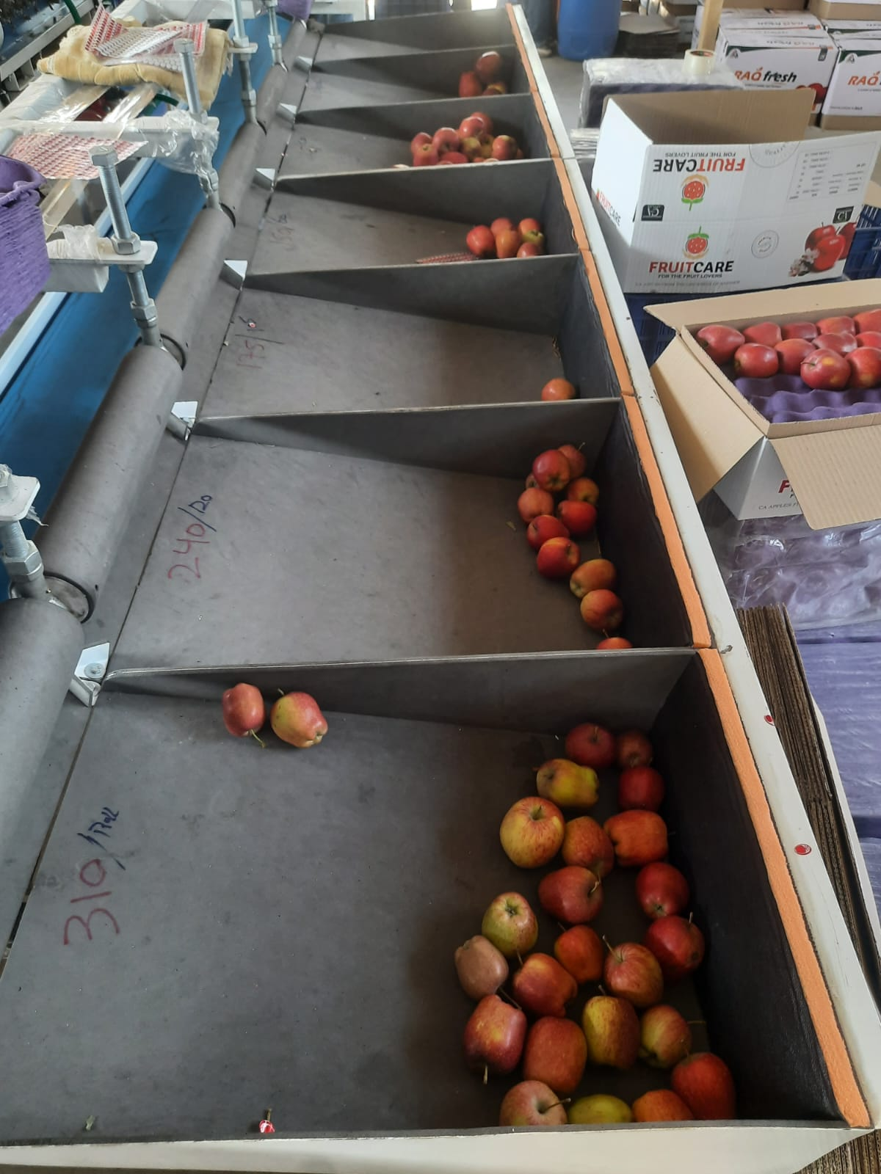 | 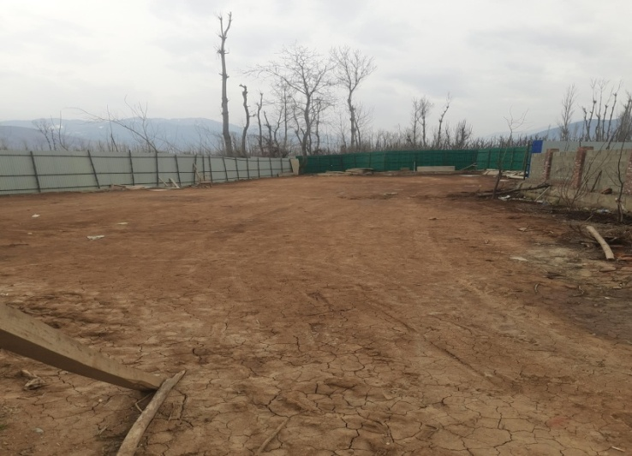
Sourcing & grading. Apples sorted at a local collection point, October 2022. | Before. The open ground identified for the Qazigund drying yard.

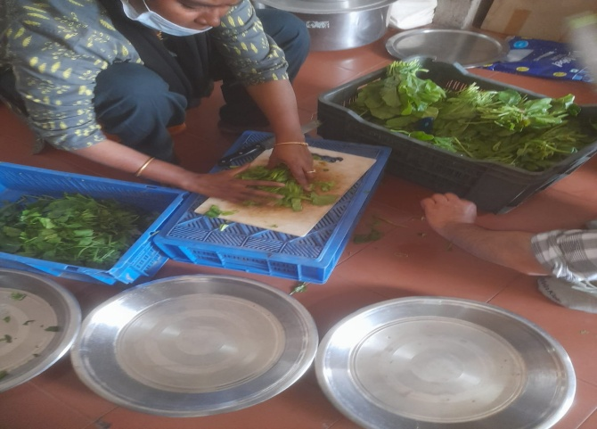 | 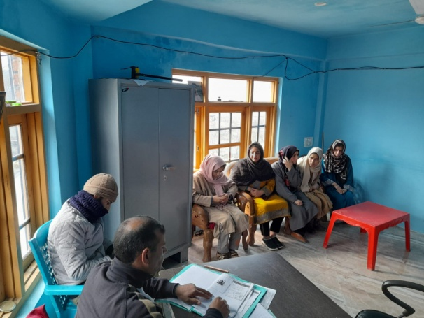
Building skills. Solar-drying and food-processing training, Hyderabad, Jan–Feb 2023. | Selecting the team. Local women interviewed and selected for training.

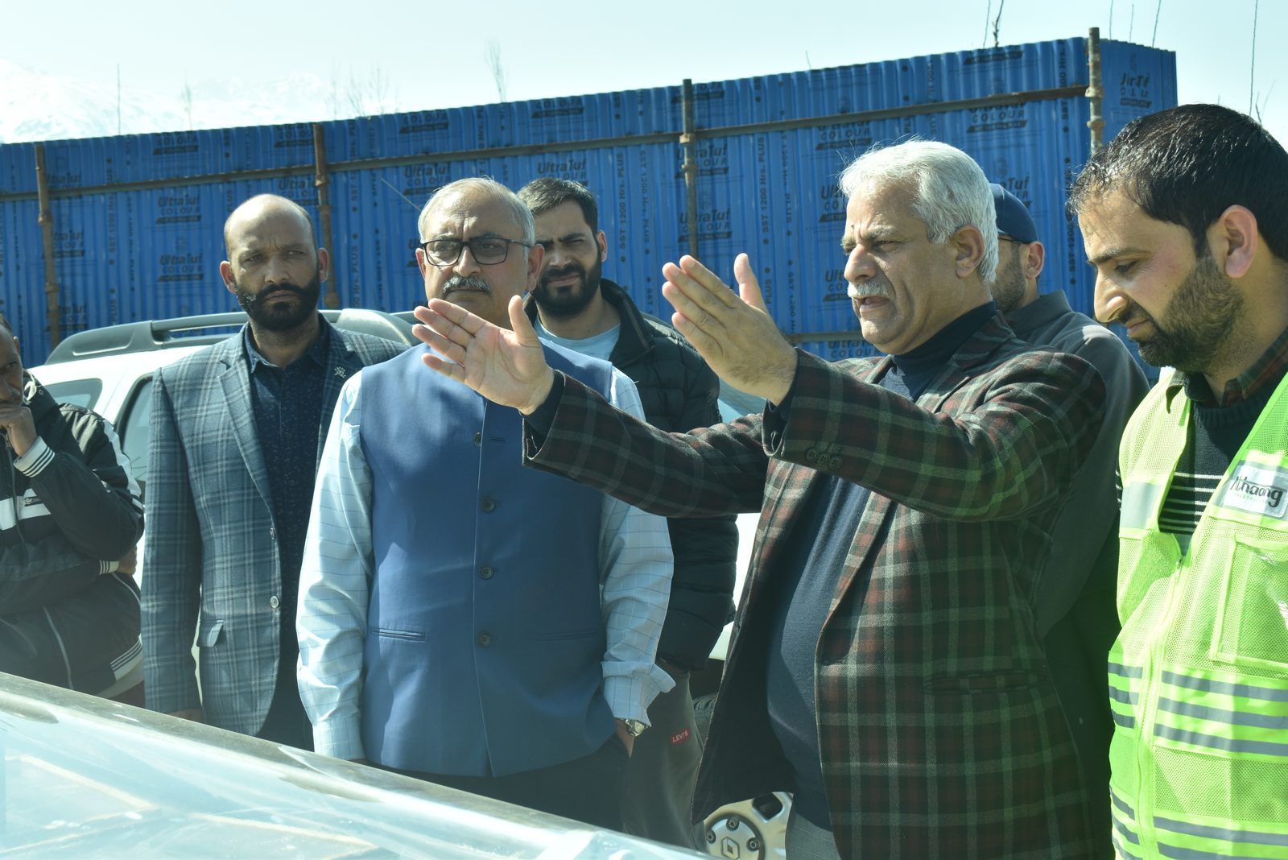
Soft launch, 11 March 2023. Gramonnati's team briefs Athaang's GM, Mr Aftab Darvesh.

THE JOURNEY IN PHOTOS — PART 2
Dichpally & Nizamabad, Telangana
Oct–Dec 2022 Leadership site visits; a roadside building in Dichpally leased and identified for conversion into a processing facility.
Dec 2022 – Feb 2023 Electrification, perimeter walls and interior finishing carried out; solar dryers manufactured and inspected at Raheja Solar Food Products, Indore, and SEED, Hyderabad.
Early Mar 2023 Solar dryers despatched from Indore and installed on site; local women selected and trained in food processing.
11 Mar 2023 Soft launch, marked with a traditional pooja at the facility.
3 May 2023 Formal launch of Project Ravi Kiran, Dichpally.

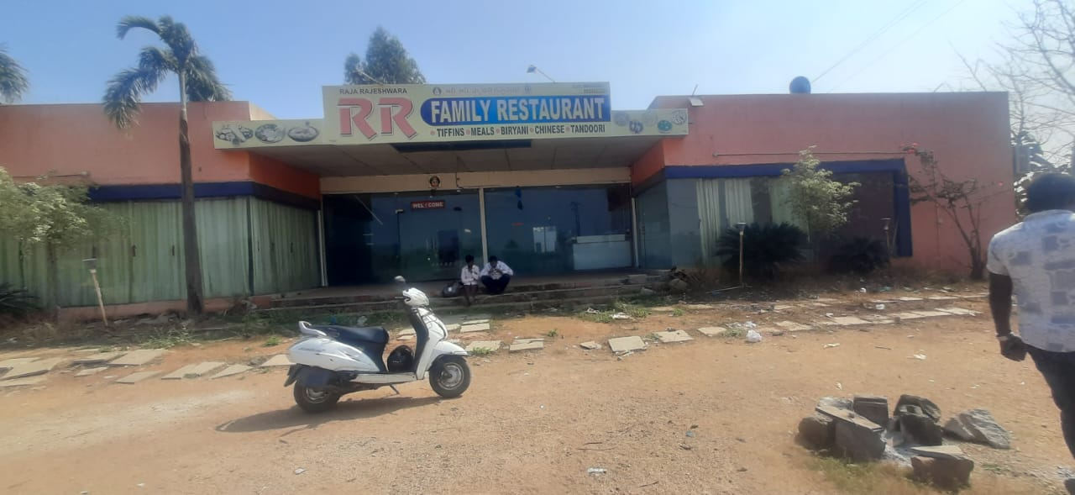 | 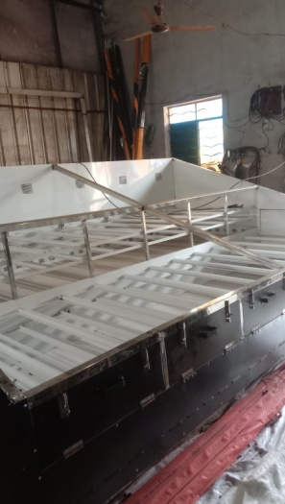
Before. The roadside building in Dichpally, earmarked for conversion. | Built & inspected. Solar dryer components loaded for transport, Indore.

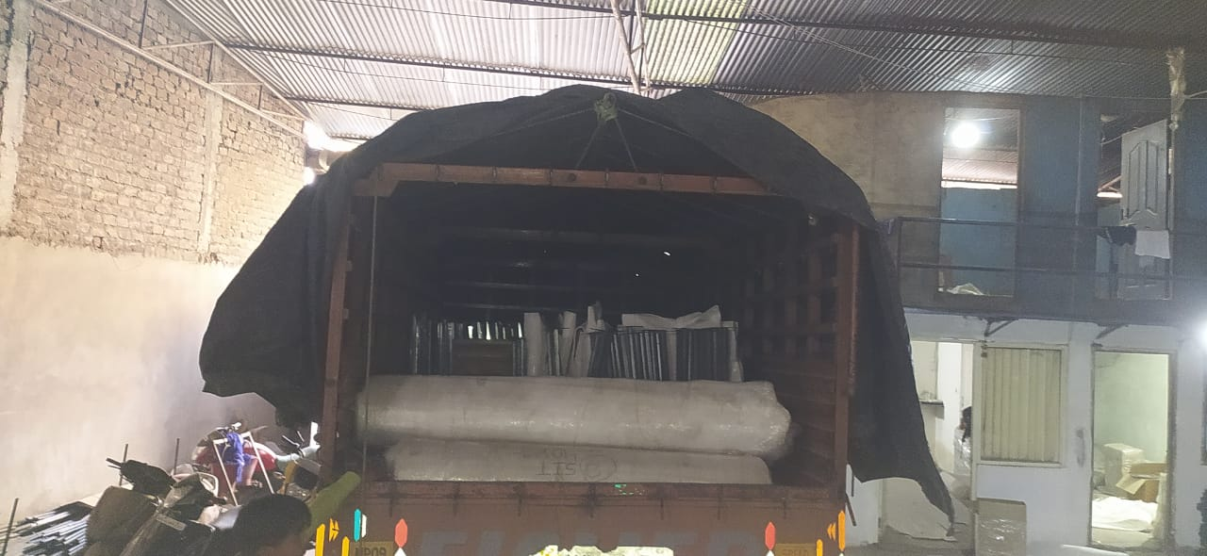 | 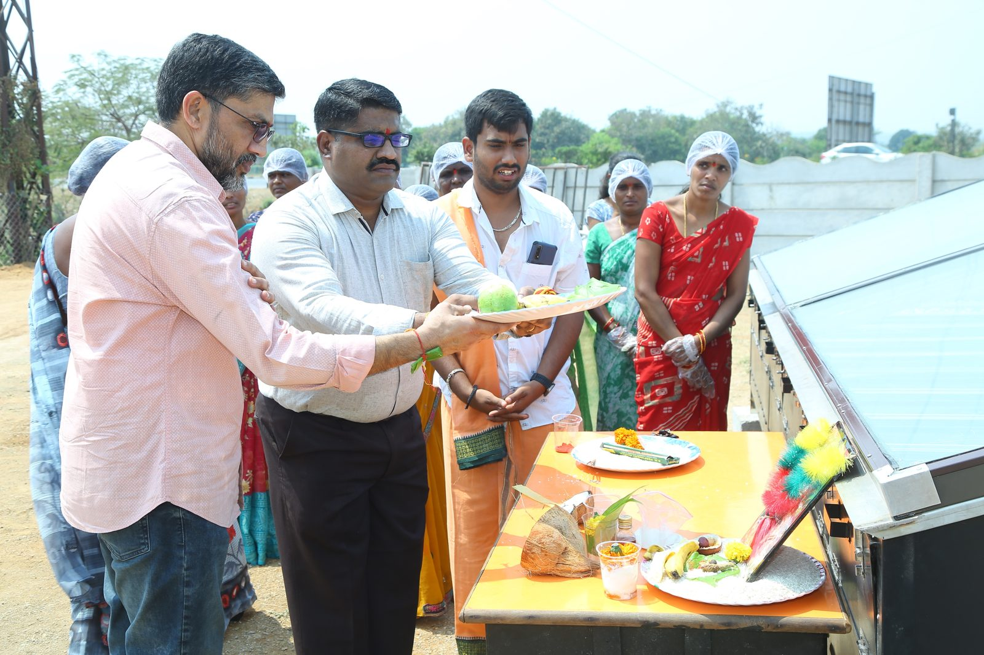
On the way. Solar dryers despatched from Indore, March 2023. | Soft launch, 11 March 2023. A traditional pooja marks the start of operations.

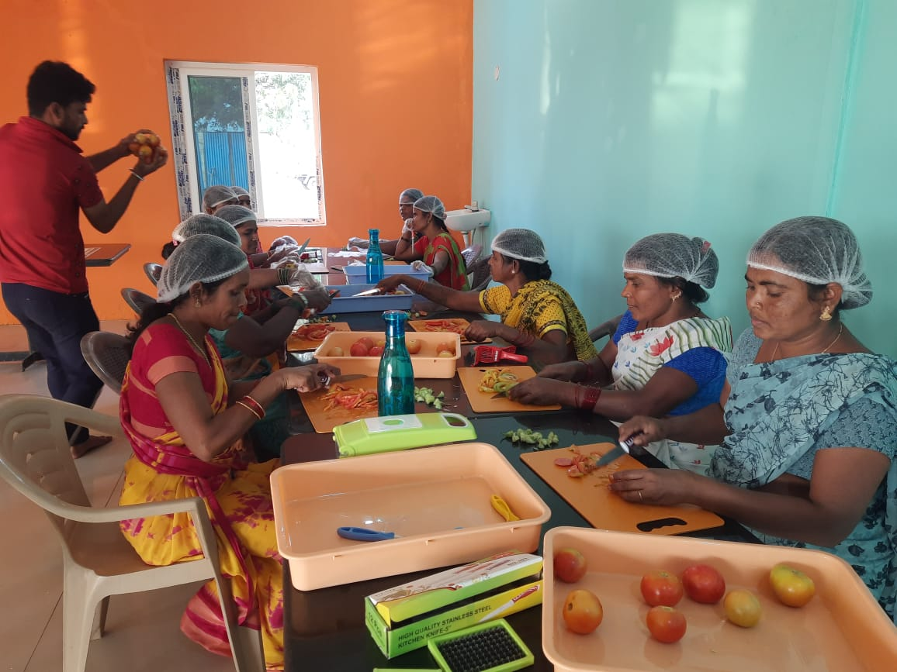 | 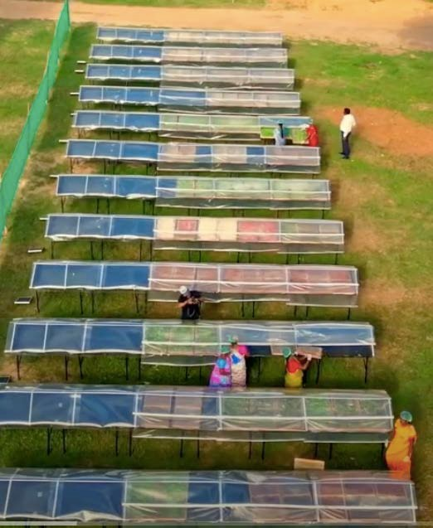
At work. Local women washing and slicing fresh tomatoes ahead of solar drying. | The drying yard, from above. Rows of solar dryers in operation at Dichpally.

Sunlight, Surplus Harvest, and Dignified Livelihoods
Project Ravi Kiran proved that a simple, zero-energy-cost technology — paired with rural women's skill and effort — can turn wasted produce into income, nutrition and dignity. It's a model Gramonnati Trust continues to draw on as it builds its next generation of community-led infrastructure.

Gramonnati Trust · Reg. under the Indian Trusts Act · 12AA & 80G Certified · CSR-1 Registered (CSR00017701)
info@gramonnati.org · www.gramonnati.org · +91 80959 99776

